Troubleshooting Tips: Hoermann Silent Drive Opener

Manual Disconnect

- To disconnect the opener simply pull the black cord and use the door manually.

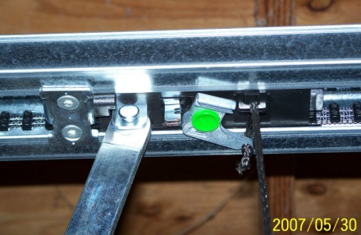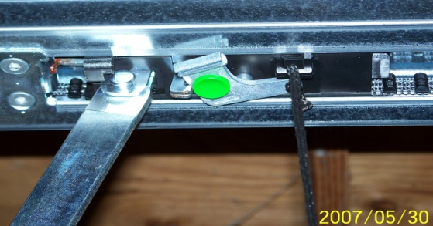
Figure 1: Carriage is engaged Figure 2: Carriage is disengaged

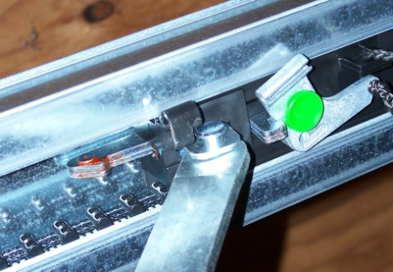
Figure 3: Locking pin – locks door in place after closing.

- To change back to automatic use you can reconnect the opener in one of two ways:
  - From the down position, push the door up manually until you hear it lock into place. Test opener to confirm reconnection.
  - While door is disconnected and in up position, push green button on disconnect lever with broom handle. Then, press wall button or remote to operate door. You will see the belt running in the rail. When the bullet reaches the door it will connect with the carriage.

Safety Sensor Information

- Green / Orange power light should remain on. If this light is off power is not getting to the sensors.
  - Check your power source to confirm it has not been tripped.
  - Look over wires connected to sensors. If any look damaged, contact a professional technician for repair.
- Red light will only come on in the event that the path of the beam is blocked in some way (by object or dust on lens) or is misaligned, and will remain on and solid until sensors are realigned.

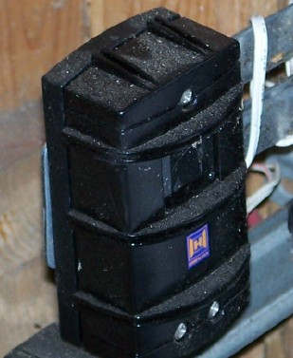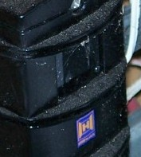
Figure 4: Sensor Figure 5: Arrow points to red or green light.

- If you attempt to shut your door and you hear a beeping sound like an alarm this is a sign that the sensors are blocked or misaligned and should be checked immediately.
- First, confirm that there are no objects or shadows crossing the path of the beam. Then clean each sensor eye with a slightly damp cloth to remove any dust or cobwebs. Red light will go out when beam path is clear
- Second, if red light is still blinking, bend bracket holding sensor slightly until the red light goes out. If this does not solve the problem, attempt same procedure on the other sensor.
- If you are unable to get the door operating call a professional technician for repair. To secure the door you can either use the manual release or hold down the wall button and close door.

To Use Vacation Lock Feature:

- Press and hold the lock button until the control button begins flashing. Let go of button; light should continue to flash until feature is unlocked. At this time no electronic operator can open the door (includes remotes & keypad). Only the inside wall control will operate the door.
- To unlock this feature, press and hold the lock button until the wall button light stops flashing. Use remote or keypad to test function.

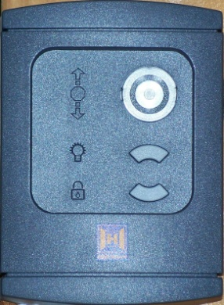

Sensors on newer Hoermann operators will have red sensor boxes with an orange power light. Lights on newer models are also larger and easier to see.
As of January 1, 2009 all newly installed Silent Drive openers come standard with this wall control.

