Genie Troubleshooting Tips

Section 1: Manual Disconnect

Q: How do I determine whether the opener is disconnected?

A: A few basic questions are:
- Does your door work manually (by hand)?
- Do you hear the motor run, but the door won’t move?
- Did someone recently disconnect the opener for manual use (such as during a power outage)?

Q: If the door is on manual what should I look for to reconnect it?

A: On a Genie opener there should be red / black cord tied to a lever:
- Genie Screwdrive – silver lever should point towards the opener when engaged, and will point towards the floor when disengaged. Push the lever up to reengage motor.

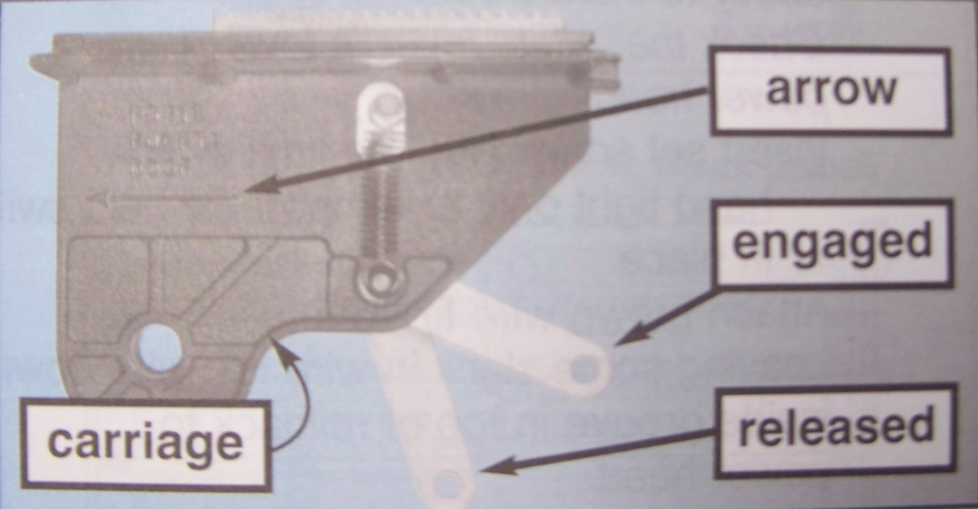

- Genie Stealth or Pro Max – silver lever should be shaped like an “N” when it’s engaged and will be shaped like a “Z” when disengaged. Push the lever up to reengage motor.

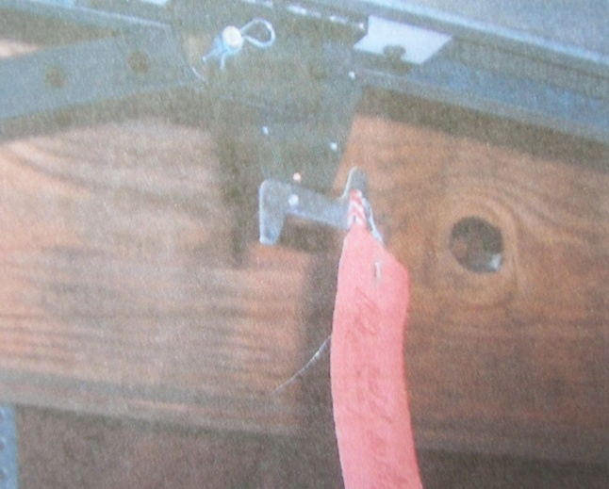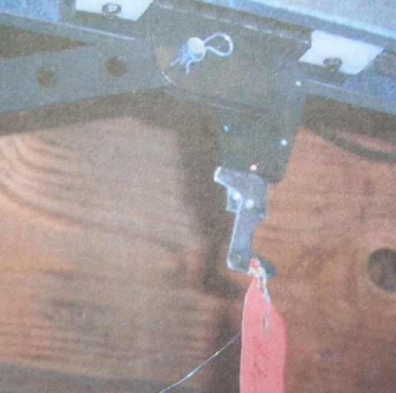

- Genie InteliG – end of red block will be pointed towards the floor when disengaged and toward the opener when engaged for automatic use. Push the block up to reengage motor.

Q: What if the lever will not stay in place?

A: Simply move the door a few inches then try again. If the lever still won’t stay, the carriage may need to be replaced.

Q: The red cord has not been pulled, yet the door seems to be disconnected from the opener. Is there any other way to put the door into manual mode?

A. The red cord is the only way to disengage the opener so that the door will work manually. Check the lever to make sure that the opener is engaged. Sometimes large vehicles with a hatch or roof rack can catch and pull the red cord.

Section 2: Sensors

Q: How do I know when the sensors are the cause of an opener problem?

A: There are a few symptoms to look for:
- From the remote the door will open but won’t close
- Will only close if you hold the wall button down until the door is fully closed. Holding the button down is an override for the sensors.
- An object (such as a plant, box, ladder, etc) is blocking the path of the beam.
- The brackets holding the sensors are bent and the sensors are not directed straight at one another.

Basic Sensor Troubleshooting Guide

Red LED light Green LED light Condition Indicated Required Action

ON / solid ON / Solid Normal Operation No action Required
OFF OFF 1. Power head has not been powered 1. Check breakers, fuses, plugs
2. Wiring from power head to sensors is bad 2. Check wiring for obvious shorts
OFF ON / Solid 1. Wiring to Red LED is missing or bad 1. Check wiring
2. Power has been interrupted 2. Remove power and reapply (See section 3 below)
2 blinks, pause (repeat) ON / Solid 1. Beam misaligned or obstructed 1. Check alignment of beam 2. Check for obstruction
2. Sensor Defective 3. Call professional technician
2 blinks, pause (repeat) OFF 1. Wire to sensor missing or bad 1. Check wiring
2. Sensor Defective 2. Call professional technician
3 blinks, pause (repeat) ON / Solid 1. Sensor receiving interference 1. Attempt to determine source of interference
2. Call professional technician
4 blinks, pause (repeat) ON / Solid 1. Red LED not sending pulses 1. Call professional technician
2. Red LED defective 2. Call professional technician

Q: Where are the sensors located?

A: The garage door safety sensors are located near the bottom of the door frame on each side of the opening.

Q: What is the first thing to check if I suspect misalignment of the sensors or obstruction of the sensor beams?

A: Lights first! Check to see whether the lights are on, off, or blinking.

- The green light** on the Genie opener should always be on & steady. If it is off, the sensors are note receiving power. Check the wires connecting each sensor to confirm that they have not come loose.
- The red light will blink if something is wrong and the pattern of the blinking is the key. If the light blinks 2 times, pause (repeat) the sensors are either misaligned or obstructed in some way. Make sure there are no obvious obstructions and that no shadows are being cast directly into the lens path. Clean the sensor lenses and check each of the sensors to make sure that the brackets holding them up are not bent. If either bracket is bent simply bend it gently back and forth in order to line it up directly with the sensor on the other side.
- If the pattern of blinking is three or four times, pause (repeat) or if it is the same as above and the green light is off, you will need a garage door service technician to remedy the problem as there may be a defect in the sensors or the connected wiring.
- If the red light appears to be solid and the same symptoms are occurring, place your hand in front of the lens to test it. If it does not blink a recent power surge may have confused the opener’s circuit board (see Section 3 for instructions). If the red light blinks when you place your hand in front of it you will need to consult a professional to solve the problem.

**Note: older Genie models may not have a green light – focus most of your attention on the red light!

Q: What should I do if the above tips do solve the problem?

A: If you have had a recent power surge or thunderstorm, the circuit board in the opener may have gotten confused. This may cause the Red sensor light to be off and the green to still be on. Follow the directions in Section 3 to reset your motor.

Section 3: Resetting opener after power surge or outage:

If your garage door opener will not respond or is behaving as though there is a sensor problem:

Locate the ceiling outlet that your opener motor is plugged into.

Unplug the opener, wait about 5 seconds, then plug it back in.

This will reset the circuit board and your door should operate normally.

Section 4: Vacation Lock Feature

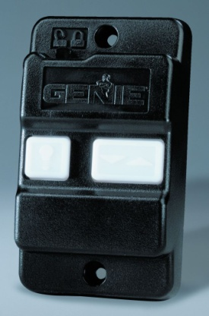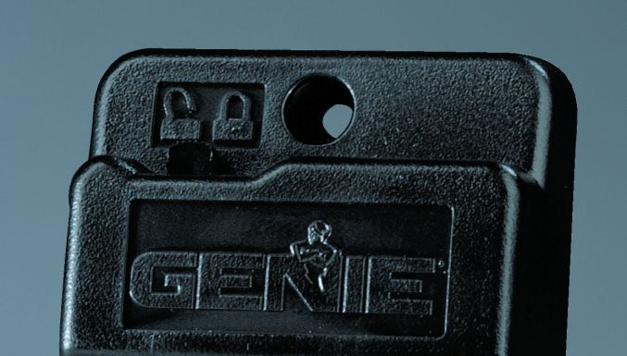

Genie IC-1 Wall Console Vacation Lock, Switch location

If you have a switch, located at the top of the Wall Console (as shown above):

Locate the switch*. You will see a picture of an unlocked & lock padlock just above the switch.

Move switch to “Locked” position. Your remote(s) or keypad will operate the door one last time to close.

To unlock this feature, simply move the switch back to the “Unlocked” position.

*Note – this feature is not intended for everyday use as switch has been known to break.

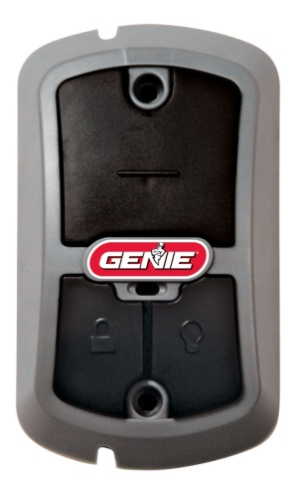

Genie NGX (IC-2) Wall Console

If you have a button:

Press button to lock opener functions. Console light will flash to indicate that functions are locked.

Your remote(s) or keypad will operate the door one last time to close.

To unlock this feature, simply hold the button until the console light is solid. Opener should function normally from all controls.

***In the event these tips do not solve your problem, please call our office @ 352-372-6479 to schedule an appointment with our service department.***

